The Mad Trapper of Rat River
Is there a member of the RCMP, serving or retired, that has not heard the story, perhaps even as a child before joining the RCMP, of the “Mad Trapper of Rat River”?
I know the story; I have read the books. I saw a horrible Hollywood movie on TV supposedly detailing the hunt for the “Mad Trapper”.
Recently, while surfing the internet, I came across two photographs of Lance Corporal Robert McDowell in Review Order strolling down the streets of London, England. Who was this member? Quick research found that Robert McDowell had been one of the members involved in the attempted arrest of Albert Johnson, “The Mad Trapper of Rat River”. This led me to search out more information on the incident via the internet. Below are several articles I have found and they contain details from RCMP reports and the recollections of those that were involved in the hunt for Albert Johnson.
There were many individuals involved in the attempted arrest and search for Albert Johnson. Some of the key players are listed below:
- Assistant Commissioner Alexander Neville Eames, O.B.E., Reg # 5700/O.209, served as the O.C. Western Artic Sub-District, Inspector and led the search for Albert Johnson. He volunteered for the Cavalry Draft and served in France during WWI.
- Constable Edgar “Newt” Millen, Reg # 9669, Honour Roll # 51 – shot and killed by Albert Johnson.
- Sergeant Richard Samuel Wild, Reg # 7536, as a Corporal wrote a memo starting the investigation of Albert Johnson. He served with the Canadian Expeditionary Force during WWI.
- Corporal Alfred Wheldon “Buns” King, Reg # 10211, a constable who was shot and wounded by Albert Johnson. He survived and later served in the Provost Corp during WWII.
- Corporal Robert McDowell, Reg # 10269, a constable who saved “Buns” King’s life by taking him by dog sled, for 20 hours in minus 40-degree weather, to the hospital. He was the last surviving RCMP member involved in the search for Johnson when he passed away in 2003. He was 94 years old.
- Major Frank Hersey, Canadian Army. One of the Canadian Army members who joined the search. Hersey was a Staff Sergeant with the Royal Canadian Signals Corps at the time of the search. He shot, and was in turn shot, by Albert Johnson. He retired as Major from the Army. He was the last surviving member of the search when he died in 2006. He was 100 years old.
- Wilfrid “Wop” May a Canadian aviation legend. Served in WWI with the Royal Air Force. History records he was pursued the by the “Red Baron” Manfred von Richtofen and lived to tell the story. May supported the search for Johnson from the air. The first time an aircraft had been used in manhunt.

In 1932, Canadians were glued to their radios. The RCMP was hunting for Albert Johnson, the Mad Trapper.
Let the story begin!
In the Northwest Territories, on December 28, 1931, investigating complaints of someone interfering with traplines, RCMP members visited Johnson’s cabin for questioning. Johnson refused. So, the RCMP travelled 200 km, got a search warrant, and returned on December 31. They knocked ... Johnson fired his gun through the door, hitting Constable Alfred King. A dogsled rushed King to medical aid. When officers returned, a three-day shootout followed. After they blew up his cabin, members discovered Johnson had escaped.
When they found him, another gunfight ensued. Johnson shot and killed Constable Edgar Millen, and vanished again.
The chase was on. Edmontonian flying ace, Wop May, joined the search, zeroing in on Johnson’s trail from above. On February 17, RCMP converged on a bend in Eagle River. With directions from May, they engaged Johnson in a final gun battle. The RCMP got their man, but not before the Mad Trapper shot another member. May flew the policeman to medical aid and then returned to retrieve Johnson’s body. The 48-day manhunt was over.
That is the Cole’s version of events!
Below are articles retrieved off the internet detailing the hunt for Alberta Johnson, including the memories of some of those involved. Grab a coffee and read on!
RCMP web site – Famous cases, events and people: A man, claiming his name is Albert Johnson, encountered by RCMP Constable Edgar Millen at Fort McPherson in July 1931 claims he spent the previous year on the prairies and that he wants to live entirely alone. The following year, Millen is told that although generally surly, Johnson is particularly so with the Loucheux Natives who avoid the man who threatens and terrorizes them. When they complain that he is interfering with their traps, Millen sends Constables Alfred "Buns" King and Joseph Bernard to investigate.
They arrive at Johnson's cabin nearly a week later. When he refuses to answer them, they trek back to the post at Aklavik to find reinforcements and acquire a search warrant. With warrant in hand and Constable Lazarus Sittichiulis and Robert McDowell added to their party, they return to the cabin, and on December 31, 1931, are promptly greeted with a hail of fire. Constable King is severely wounded and the posse falls back. On January 9, 1932, Constables McDowell, Sittichiulis, Millen and Bernard, return with Inspector Alexander Eames, trappers Karl Garlund, Knud Lang and Earnest Sutherland, 42 dogs and 20 pounds of dynamite. A 15-hour siege follows but still, Johnson does not surrender. The men return to their post to restock their supplies. Twenty-one men, including 11 Loucheux Natives, return to the cabin on January 16, but this time Johnson has escaped, probably heading for the Alaskan border. With enough food to last them nine days, Millen, Riddell (a soldier), and two trappers, set out to find the elusive Johnson.
On January 30, the party discovers Johnson who kills Constable Millen. This only serves to intensify the Force's determination to catch the fugitive. With the help of an experienced young pilot, Wilfred "Wop" May, the RCMP uses the first plane to assist in the apprehension of a criminal. The team sets out on February 3, in pursuit of the criminal. The final shoot-out between the trapper, Albert Johnson, and the RCMP occurs on February 17, 1932, when a Royal Canadian Corps of Signals, Staff Sergeant H. F. Hersey, is injured and Johnson is killed. The Mounties "get their man."
On Johnson's person were found 32 kidney pills, $2,410 dollars in large bills, both Canadian and American (worth approximately $60,000 today), and two glass jars, one containing five pearls, and the other, seven gold pieces of dental work. He was also found with a .22 Winchester rifle, a model 99 Savage, a .30-30 rifle, 39 .30-30 ammunition shells, 84 .22 shells and four shotgun shells.
Who was this "mad trapper of rat river?" To this day no one has been able to prove who the man calling himself Albert Johnson really was and why he acted as he did. Many researchers have tried to solve the puzzle and one in particular, Dick North, has written several books. Even with his identity unknown, the RCMP, with the help of the first air search team, did a good job apprehending the man.

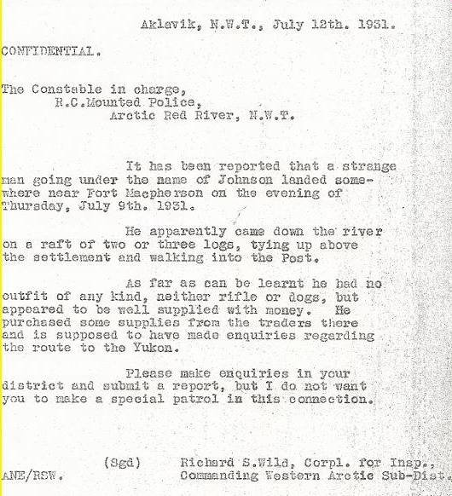

Corporal Wild’s memo that started it all!

Who was the Mad Trapper of Rat River? Allan Phillips – October 1. 1955 – Macleans Magazine
It was hot July day in 1931 when the man called Albert Johnson came floating down Peel River to begin his infamous odyssey.
He beached his raft above Fort McPherson and strode back to the settlement, a cluster of whitewashed cabins and a log trading post. To the northeast stretched the flat green delta of the Mackenzie, obscenely lush, a malevolent marsh that passed imperceptibly into the Arctic sea. Westward rose the foothills of the continent’s northernmost mountains and beyond them the ice-crowned peaks veined red with iron through which he was soon to lead the Royal Canadian Mounted Police in Canada’s most sensational manhunt.
On three continents newspaper readers would marvel day by day at the exploits of this ruthless adventurer. No one will ever know his real name but he will live in memory by the name the papers gave him, the Mad Trapper of Rat River—though trapping was only an incidental skill and he wasn’t mad, except in the sense of harboring hatred. On the contrary, he was as shrewd, resourceful and resolute a killer as the north has ever known.
He came into the trading post at Fort McPherson, brusquely shouldering past lounging Indians, a medium-sized man, thirty-five to forty, slightly stoop-shouldered, sun-reddened, fly-bitten - most unlikely material for romance. Bill Douglas, the factor, sized him up as a loner. He had obviously lived alone in the wilderness for months, yet he curtly parried questions, keeping his tension bottled inside him. He spoke only to order supplies.
In the next ten days he spent fourteen hundred dollars with Douglas. He said he was getting an outfit together to trap in Rat River country. He was carrying several thousand dollars—very strange, since a trapper usually sends his money outside. And his outfit wasn’t that of a man who intends to winter in one place.
He had nearly completed his outfitting when a very tall lean man in a khaki shirt and stiff-brimmed Stetson came paddling into the post.
Constable Edgar Millen, widely known as Newt was on a routine patrol from Arctic Red River RCMP detachment thirty miles southeast. Douglas was glad to see him; the thirty-year-old Mountie was highly regarded on the delta for his (good) humor, common sense and bushcraft.
Millen had heard of the stranger from wandering Loucheux Indians. He wanted Douglas to tell him more. In the Arctic, as Douglas knew, a life often depends on the knowledge the Mounties have of his habits and movements.
“He’s bought a nine-foot canoe from an Indian," Douglas said. “The questions he asked me, I figured he’s going up Rat River, over the mountains of White Pass, down the Bell, down the Eagle and onto the Porcupine. Another reason I that way, Newt - some Loucheux passed by upriver. He asked them where he was. When they said he was on the Peel he was pretty annoyed.”
Millen digested this information. The waters of the Peel and the Porcupine are in Yukon only a few miles apart. A man could easily mistake one for the other. But the Peel flows into the Territories, the Porcupine into Alaska.
“I better talk to him,” Millen said. “He does (not) know the Rat.”
Millen found Johnson down on the steamboat landing, assembling his gear. The Mountie introduced himself. Johnson shook hands reluctantly.
“Anything I can do for you?” Millen asked.
“No, no,” Johnson said hurriedly, "I’m just, pulling out.” From his accent Millen tabbed him as a Swede from the northern States. He had an upturned nose in a broad flat face and his features were curiously stiff, as if he were constantly struggling with the hostility that came seeping to the surface from some inner reservoir. "How’d you come in?” Millen asked.
"Mackenzie River. I been working all last winter on the prairies.”
Millen knew it was a lie. Douglas had told him the stranger had come from upriver. He let it pass. "Going to stay around here long?” Millen asked.
"Maybe. I don’t know yet.”
"If you want to trap, I can give you a license now. That will save you making a trip into Arctic Red River.”
"I haven’t made up my mind,” Johnson said evasively. "I may go over Rat River portage.”
"Alone?”
Johnson scowled. He made no answer.
"You ought to hire a guide,” Millen said evenly.
It was as if the thought had triggered some mental thermostat. Anger flooded into Johnson’s voice. "No!” he said violently. "I don’t want people bothering me. I like to live alone. You police just cause me trouble. I don’t want nothing to do with you.” He recovered himself and a hint of shrewdness came into his voice. "You want to know all about me? All right. I’m not staying here. If I’m not staying here you don’t have to know all about me, eh?” He met Millen’s suddenly sharpened gaze for the first time.
Millen had been trying to tell him that one man alone could not make his way up Rat Rapids. But Johnson’s blue eyes, pale as sea ice, were filled with cold unreasoning hate.
Millen shrugged and walked away.
Just before Christmas the big snows came and the Loucheux, a nomadic tribe, came straggling into Arctic Red River to celebrate Yuletide.
The Indians were frightened and incensed. The strange white man called Albert Johnson had failed to get up Rat Rapids. He was wintering at the mouth of Rat Canyon. He had built his cabin near a trapline used by the Loucheux for centuries and was springing their traps, flinging them into trees, sometimes substituting his own. When they went to his cabin to reason with him, the Indians told Millen, Johnson threatened them with a rifle.
"You’d better go up and see what it’s all about, Bunce,” said Millen to A. W. King, second constable at the RCMP detachment.
King set out by dog team the day after Christmas. He was in his late twenties, a powerful hearty man with a red round puckish face. With him went Joe Bernard, an Indian employed by the police. They knew the cabin site. During the Yukon gold rush hundreds of prospectors, shipwrecked on Rat Rapids, had wintered there and died of scurvy. They had named it Destruction City.
On the third afternoon, with eighty miles behind them, and the hills on both sides narrowing to Rat Canyon, they swung round a bend in the frozen river and sighted Johnson’s cabin. It stood in a clump of willow and spruce on the snow-covered flats of the left bank, square and squat—only three or four logs showed above the drifted snow. In the grey half-light of the Arctic day it seemed oddly sinister.
The Mountie left Bernard with the dogs in the shelter of the riverbank and walked on his snowshoes through twenty feet of brush to the cabin. Beside the door stood a pair of homemade snowshoes, strips of caribou hide strung on bent willow frames.
King rapped. "Mr. Johnson!” he called.
Smoke plumed up from the stovepipe but there was no reply. He walked around the cabin. About eight by ten, he judged. It seemed to be sunk three or four feet into the gravel bank, a strange thing when ordinarily a man’s first concern is warmth. The roof was of poles reinforced with sod frozen nearly as hard as concrete. There was sod between the heavy logs of the walls. Then he noticed the holes. They were at every corner, driven through the frozen sod just above the drifted snow: rifle loopholes, commanding all approaches.
From the Hut Came an Answer
King peered in the tiny half-frosted window. A few inches away a wild-eyed face glared out at him from the gloom.
King knocked again, shouting his name and business. The man inside was silent. The Mountie cursed. He would have to trek to Aklavik and back, one hundred and sixty miles, to pick up a search warrant from A. N. Eames, the inspector in charge of the RCMP sub-district.
It was mid-morning, December 31, when King once more pulled up his dogs on the bare river ice below Johnson’s cabin. Inspector Eames had at first been angry at all this needless work. He had sobered as King described the cabin, and he had detailed two trustworthy men to accompany Bernard and King on the trip back: Constable R. G. McDowell, a handsome quiet twenty-two-year-old, and a tall pleasant-faced Loucheux, Lazarus Sittichiulis. They’d been driving hard; King was impatient to finish this business in time to get to Bill Douglas’ New Year’s party being held at Fort McPherson.
"You stay with the dogs, Joe,” he told Bernard. "Lazarus, you scout around to the back. Jack, you cover me, will you?” McDowell edged behind a riverbank spruce.
King strode toward the cabin. The wind was rising, whipping away the smoke that still came from the chimney. He hammered hard on the door. "Are you there, Mr. Johnson?”
He thought he heard movement inside. "Mr. Johnson!” he called again, testing the door with his shoulder. "I have a search warrant. Open up or I’ll have to break the door down.”
There was no answer. Again, he bunted the door. It gave a little. Then he felt himself hurled to the snow by a smashing blow in the chest; he heard a shot, it seemed to come from very far away. Bullets came splintering through the door and went whining overhead. He heard McDowell calling, "King! Can you crawl? Crawl away from the cabin. Make for the brush.”
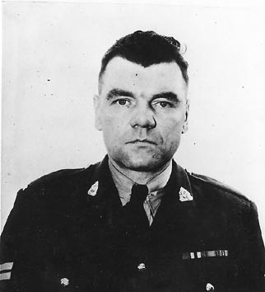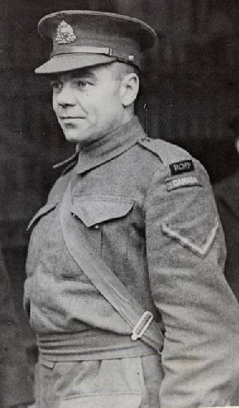
Alfred Wheldon “Buns” King – Reg # 10211- first to be shot be Johnson and lived to tell the story.
Now he heard McDowell’s rifle and King got to his feet, staggered into the brush and collapsed. McDowell was still shooting, drawing the fire of the man inside. King began to crawl. Then Lazarus was helping him down the bank.
His head cleared as they bandaged his bleeding side, fumbling, hurried by the 45-below-zero cold. They bundled him in eiderdowns and lashed him to the toboggan.
"You want me to go back and shoot ’um now?” Lazarus asked.
McDowell shook his head. "We’ll get Bunce fixed up first.” McDowell was trying hard to be reassuring. But the bullet had smashed through King’s ribs, a blizzard was coming up, the dogs were already weary from the long trip out and they had eighty miles to travel.
Through swirling ground storms McDowell and the two Indians broke trail most of the day and night, easing King’s heavy body down the portages. Their thighs were numb as they carried the wounded Mountie into Aklavik’s Anglican Mission hospital.
"The bullet’s pierced his stomach,” the resident doctor, J. A. Urquhart, said. "It missed his heart by an inch and his lungs by less.” Peritonitis, the doctor said, had been staved off by King’s fine condition and empty stomach, for in his hurry to get to the New Year’s party King had stopped only once the day before for food. Luck, and McDowell’s record twenty-hour run, had saved his life.
“You May as Well Give Up”
The news of King’s shooting spread quickly through Aklavik, a town of some two hundred natives and thirty whites. Inspector Eames, a forceful official of forty-five, had no trouble picking a posse: himself, McDowell, Sittichiulis, Bernard, and three trappers in town for New Year’s, Ernest Sutherland, Karl Gardlund and Knud Lang. They figured Johnson was more likely to give himself up to a party that included some of his own kind; they still thought of the man as a bush-crazy trapper.
As soon as the RCMP dogs had recuperated they set out, packing some dynamite to breach the walls of the cabin which King had described— rather imaginatively they thought—as a fortress. Camping at the mouth of the Rat they were joined by Newt Millen; he had picked up a radio message from UZK Aklavik, "Voice of the Northern Lights,” an amateur station run by army signalers.
Inspector Eames decided that the winding willow-fringed Rat offered Johnson too many chances for ambush; he hired an Indian guide to take them overland. In darkness and storm the Indian overshot the trail to Rat Rapids. They were eight days out, with only two days’ dog food left, when they worked down the rim of Rat Canyon onto the flats below.
It was noon but the light was grey as dawn. The storm raged less furiously here. Eames strung out his men behind the chest-high riverbank that bent around the cabin on two sides. They crouched, listening, the sweat from their morning’s march congealing clammily inside their parkas.
A clatter of kitchen utensils came to them clearly on the wind. Eames lifted his voice in a drill-square bellow: "Johnson! This is the Royal Canadian Mounted Police. Come out. There’s no serious charge against you. The man you shot isn’t dead.”
There was no sound but the wail of the wind.
"Come out!” Eames shouted again.
"You may as well give up. There’s eight of us here - three trappers. Don’t make it tough for yourself.”
No answer came from the lightless cabin squatting among the trees.
Eames passed the word to the crouching men. They clambered up over the bank. Gunfire streaked from the cabin loopholes. The police party dropped to the snow, inching forward from bush to tree, firing at the loopholes that continued to spit flame. Two men got to the door, half smashing it in with their rifle butts. A fusillade drove them back.
They huddled behind the riverbank. Eames tried persuasion again. Johnson answered with a shot. The inspector knew now, by a fleeting glimpse when his men had broken the door, that Johnson was lying shielded by a double barrier of logs sunk at least three feet in the earth.
The police party were shooting in woolen gloves, their outer mitts dangling by a thong from their necks; some had their hands frostbitten. Leaving two men on watch, Eames withdrew down the river, put up tents and kindled fires. "Let’s get the dynamite thawed out,” he said. "We’ll throw in a few small charges and try and open a hole in the wall. Not too big - we don’t want to kill him.”
The dynamite, exploding in the open, had no effect. At midnight Knud Lang said, "Maybe if I could get up on the roof, I could stun him with a big charge.” Eames agreed.
Running a gantlet of fire, Lang made the roof, scrambled up, lit the fuse, flattened out for the blast - then kneeled and peered down the jagged hole. Through a swirl of acrid smoke, he saw Johnson crouching on the floor, a sawed-off shotgun in one hand, a revolver in the other. The two men stared into each other’s eyes. Then Johnson snapped a shot. Lang jumped back and dodged to the riverbank. He knew now that Johnson had a shotgun, a revolver and two rifles, probably a .22 and a 30-30 Savage.
They threw flares. In the flickering light they tried to glimpse Johnson between logs where the chinking had been blasted out by dynamite. Johnson stayed out of sight. Eames had the posse fake a rush while Millen moved stealthily in. The crunch of his snowshoes gave him away and Johnson’s guns forced him back.
At 3 a.m. Eames hurled the last of his dynamite against the front of the cabin. In the aftermath of its violence, he ran for the half-shattered door, Gardlund running beside him holding a flashlight to spot the target. A few yards from the door Gardlund switched on the light. It was smashed from his hand by a bullet from Johnson’s rifle. Johnson had the advantage of what little light there was. They retired to the riverbank.
The inspector studied the drawn bearded faces of his posse. It was fifty degrees below zero. Dead-white patches of frostbite showed on some. Cold and spasmodic excitement had drained their strength. They needed rest and food and he had only one day’s supplies left.
The inspector hurried his posse, angry and frustrated, back to Aklavik where he arranged for more supplies and men. Two ingenious army signalmen, Sergeants Frank Riddell and Frank "Heps” Hersey, fashioned crude grenades and homemade gas bombs —beer bottles filled with sulphur and gunpowder. Eames still intended to take Johnson alive if possible but he no longer thought him a half-crazed hermit. Either he was a fugitive or some crime lay on his conscience. The amateur radio station alerted all trappers. Far to the south, newspapers were headlining the story of the unknown gunman, the Mad Trapper of Rat River, who from his Arctic fortress had so successfully defied the famous Mounted Police.
Constable Millen and Karl Gardlund returned to the battleground in advance of the main party. Hoarfrost lay unbroken over the trampled snow and upon the half-smashed door. An unmistakable air of desertion clung to the dwelling.
They opened the door and stared down in amazement: the floor was a series of bunkers, exactly body-size, hacked from the glass-hard gravel in front of each loophole. They were lined with spruce boughs and fires had been built against the wall at the rear to reflect heat into them.
A careful search revealed no furs, no papers. There was only a litter of empty shells, some half-raw caribou scraps. Outside, the waning windstorm had swept the river ice clear of tracks.
Eames and his posse arrived two days later, January 17. They had set up a base camp at the mouth of Rat River. They agreed that Johnson would not go far in such weather. He had no dogs to pack supplies; he would have to hunt or trap as he traveled. Somewhere in the snow-laden brush of the canyon floor above, half a mile wide with walls rising six hundred feet in places, somewhere along the willow-lined creeks that gullied out from the canyon, he would be hiding.
They combed the canyon for four days. Johnson had vanished. Eames withdrew most of his men so that he could leave nine days’ rations with Constable Millen and three of the best shots and bushmen, trappers Karl Gardlund and Noel Verville, and Army Signals Sergeant Frank Riddell.
In pairs the quartet stalked their quarry through the scrub of the creek beds. Half-circling, working ever deeper into high country, they prowled tensely through thickets that might shelter hare and ptarmigan, the game Johnson needed to stay alive. They found two caches of caribou which Johnson had killed in the fall and watched them for several days through field glasses. Johnson did not return.
Occasionally, in a creek bottom, they picked up his trail in deep snow, lost it, cut across a ridge and found it again. His technique was clear. He traveled the glare ice along the creeks and along the high hard-packed wind-swept ridges between. At night he would trek up a stream bed, pick a campsite, circle around it, backtrack, and bed down just off his trail where he could ambush his pursuers. Slowly but surely, he was heading for the Divide. Beyond the mountains, across the narrow neck of the Yukon little more than a hundred miles, lay Alaska.
The Quarry in Their Sights
January 28 was windless. Riddell picked up the week-old trail, lost it as usual, and was laboring over a ridge when he sighted a faint blue haze rising out of the gorge beyond, the only sign of life in a landscape as cold and dead as the moon. Excitedly he signaled to Verville a couple of ridges away and the two men crawled to the cliff edge and gazed down.
Fifty feet below in a thicket of brush a man sat tending a campfire. Little trails ran out from his fire like spokes in a wheel but no tracks led in or out of the thicket. "He snares what he needs right there,” Verville whispered.
Riddell was mystified by one trail; it led behind the gravel-clotted roots of an upturned spruce. He raised his rifle, sighted, then lowered it. "I don’t think we could place our shots in this light,” he said. "We might kill him if we shoot.”
"I don’t want to be brought up on a manslaughter charge,” Verville said. "We’re not policemen. Eames didn’t swear us in. We better go back and get Newt.”
Next morning the four men peered from the lip of the gorge on a smoldering fire. Johnson was not in sight. "He must be sleeping,” Riddell said. "I wonder why the trail behind those roots?”
"I don’t like it,” Millen muttered, strangely preoccupied. The others glanced at each other; Millen was a man who took risk lightly; his greatest fault was his sense of personal invulnerability.
The mood passed. "Frank,” Millen said to Riddell, "you and Karl circle the ridge, get down in those willows —just behind him there on the creek bank. As soon as Noel and I see you’re set, we’ll slide down in front.” To their left the sheer drop eased off into a slope. "If he comes out and starts shooting at us, you guys pick him off. If he doesn’t lift his gun he won’t get hurt.”
From their screen of willows Riddell and Gardlund stared down their gun barrels into the tiny campsite only twenty yards away. They heard the Mountie and Verville come crashing down the slope, breaking bushes, talking loudly. They caught a blurred glimpse of Johnson as he flung himself into the snow trench that led behind the roots of the upturned spruce. Too late to warn Millen, they realized that the gravel-matted roots formed a natural barricade. Johnson had picked his second battleground.

Death in the Snow
In the frosty silence they heard Johnson cough and check his rifle. Then Millen’s voice:
"Johnson! Cut out the shooting. You can’t get away. Put down that rifle before you kill someone.”
Johnson said nothing. They glimpsed Millen and Verville edging forward, then Johnson’s gun cracked twice. Gardlund, waiting, fired at the stabs of flame.
The silence settled again. "I think maybe I hit him,” Gardlund whispered. Riddell crawled over to join Millen. They listened, then climbed the bank.
Slowly they waded through waist-high snow toward the barricade. Something was wrong, Riddell thought. What looked like a stick protruding through the roots caught the light and gleamed metallically. "Look out!” Riddell yelled and dodged behind a poplar.
A shot ripped bark from the trunk and stung his cheek. He leaped for the bank and slid over in a blinding flurry of snow as Johnson fired twice more and Millen answered.
Riddell looked back up. Millen, kneeling, was coolly aiming toward the blue-black gun barrel that jutted through the barricade. The gun barrel flamed. Slowly, Millen rose, spun and fell face down in the snow.
Riddell fired at the rifle barrel and Johnson jerked it back. "Are you hurt bad, Newt?” called Riddell. Millen lay motionless.
Gardlund and Verville came crawling over. They all climbed the bank. Riddell and Verville opened fire and Gardlund slithered through the snow to where Millen lay. He unfastened Millen’s moccasin laces, tied them to make a handle, and dragged Millen back over the bank.
Millen’s face was grey, the eyes open, staring. A small stain darkened his khaki parka over the heart. The body had already begun to freeze. They checked Millen’s rifle. "Look at this!” Riddell said. A missing screw had caused it to jam.
Night was falling. They huddled around the corpse beneath the bank in the gathering dusk and heard the killer coughing only a few yards away. They debated what to do. It was no longer an adventure. Death with its terrible finality had sobered them. It was incredible that Millen was dead.
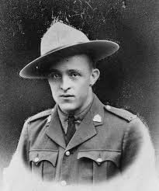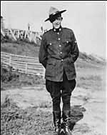
Edgar “Newt” (also known as “Spike”) Millen – Reg # 9669 – Honour Roll # 51 – shot and killed by Johnson
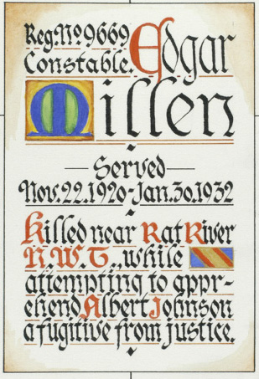
Millen’s Silent Partners Card - handed out to cadets in training
They could see no way of capturing Johnson. They tied spruce branches over Millen’s face to keep the ravens from pecking his eyes and hoisted the body up on the bank where weasels would be less likely to find it. Gardlund and Verville agreed to watch Johnson while Riddell went back to tell Eames.
Millen’s murder, broadcast over UZK, brought angry trappers from all over the delta to Aklavik. On February 4, Inspector Eames and a posse of ten picked men surrounded the scene of Millen’s death. They were met by Gardlund who told them ruefully that Johnson had slipped away in the night. "We haven’t a clue which way he went. The only place he left tracks is where he looked at Millen’s body.”
For three days Johnson eluded them, backtracking cleverly, sometimes reversing his snowshoes. Eames was once more low on supplies when he heard a distant drone and a ski-equipped monoplane came swooping low over the camp, waggled its wings and made a perilous landing a few miles west high on a mountainside.
The pilot was Captain W. R. May, better known as Wop, a superb bush pilot, the World War 1 ace who dueled till his guns jammed with the German ace von Richthofen, whom May then decoyed to his death by a fellow Canadian, Roy Brown. Now, summoned by Eames from Edmonton, thirteen hundred miles south, May became history’s first pilot to give direct aid in a manhunt.
At great risk, for winds were swirling snow a thousand feet in the air, May solved the problem of supply that plagues all Arctic police work. On February 11 the sky cleared for an hour and May, scouting far ahead, saw where Johnson had climbed a high spur, studied the cloud-wreathed peaks, then had struck out unerringly for Bell Pass. He had made his break. He was heading for Alaska, traveling fast and straight at last.
The Indian trackers in Eames’ posse were certain that no man could cross the Divide alone on foot in a storm— certainly, no man ever had. Johnson was fighting the wind-swept eastern face of the continent’s least-known mountains. He had no dogs; he was backpacking a kit heavy with guns and ammunition. He had no food and no way to warm himself, for above the treeline there was neither game nor wood. They would find him dead, the Indians said.
At nightfall, Constable W. S. May (no relation to Wop May), from the lonely RCMP detachment at Old Crow, near Alaska, mushed in with an Indian guide. He handed Eames a letter from the trader at La Pierre House on the other side of the mountains. Indians hunting moose had seen strange tracks made by big snowshoes with a queer twist to one frame — short - spaced tracks, as if the man who made them was tired. They led down Bell River and they were fresh.
Johnson had crossed the Divide.
Next day, February 13, Wop May landed Inspector Eames, Sergeant Riddell and trapper Karl Gardlund on the deep snow of Bell River in front of La Pierre House. The following afternoon May managed, in spite of fog, to get aloft for an hour’s reconnaissance.
On these windless western slopes, the snow lay deep and soft; Johnson's tracks were in plain sight along the Bell. At the mouth of the Eagle River they disappeared. He had taken his snowshoes off and stepped along in the maze of tracks left by a great herd of migrating caribou.
By February 15, when Constable May and his posse of eight reached La Pierre House, Johnson had a four-day start. A huge white-haired trapper, an old - timer named Frank Jackson, showed them portages that took them fifteen miles down the Eagle by evening of February 16. Here they picked up Johnson’s trail where it left the caribou herd. It was no more than thirty-six hours old.
At twelve o’clock on the following day, with snow clouds thick overhead, they were strung out along the Eagle, between high willow-fringed banks. Signalman Heps Hersey, Olympic boxer and Fredericton track star, urged his lead team round a bend and saw a man walking toward him. It was Johnson, backtracking.
Both men stopped, astonished. Johnson drew on snowshoes and ran to one side out of sight. Hersey snatched his rifle from his toboggan and rushed forward for a clear view. Johnson was trying to climb the steep south bank, trying to make the shelter of the brush.
Hersey dropped to one knee and fired. Verville fired from behind him. Johnson whirled and snapped a shot. Hersey toppled over.
Verville ran to Hersey’s side. The others were coming up now, spreading out along both banks, passing back the word to Eames and Riddell far in the rear, "It’s Johnson! Johnson’s up ahead!”
Johnson, unable to climb the south bank, was running back up his trail toward an easier slope on the north bank, stopping to fire, reloading as he ran. He was drawing away from the posse who were shooting and calling, "Surrender!” when he stumbled as if hit in the leg. He wriggled out of his pack, flattened out in the snow behind it and opened rapid fire.
All around him now was the posse working into position. They stared through their gun sights at him from the deep snow of mid-river, from the thick brush of the banks alongside and above him.
"Johnson!” Eames called. "This is your last chance to give up!”
Eames’ voice rolled emptily out across the frozen white stream. A trapper shifted position and Johnson fired. Grimly the posse poured out a volley.
Johnson squirmed as the bullets struck. At ten past twelve he was still, one spot of black in a white waste of snow.
Constable May approached warily. "He’s dead!” he called to the others. A bullet had severed Johnson’s spine as he was reloading his rifle. Five other bullets had hit him but he had uttered no cry. From beginning to end the renegade of Rat River had kept his silence.
The plane had appeared in the sky as Johnson died. It taxied to within a few yards of where Hersey lay writhing, cursing a shattered elbow. Johnson’s bullet had ripped across his left knee, entered his elbow, had come out his upper arm, smashed two ribs and pierced his lungs. He had not realized yet that he was shot in the chest and was hemorrhaging steadily.
Wop May and Constable May gave Hersey a sedative and they lifted him into the plane. Riddell and Jack Bowen, the plane’s mechanic, held him still. May took off into clouds like grey syrup. At treetop height he roared at full speed down the twisting river, his fingers like feathers on the controls.
The plane sliced through the buffeting winds of Bell Pass and rocketed down the canyons, wing tips almost shaving the rock walls. In less than two hours following the shooting, Dr. Urquhart in Aklavik was tying off Hersey’s broken arteries.
"You got here just in time,” he told May. "He’ll live.”
Back on the river, the posse gathered round the corpse in the snow, the husk of the man called Albert Johnson. For weeks their life had centred in this elusive figure. He had loomed in epic stature in their minds, a man whose fierce unyielding self-destructive tenacity would pass into folk tale and folk song.
Lying limp in the snow, he was far from heroic. The seven-week chase had drawn all surplus fat from his body, never large. His head already resembled a skull, its contours shaped by the wispy sweat-soaked hair. His pale eyes stared from dark fatigue-swollen caverns. The fury that had sustained his will had remained with him to the end, stretching back his lips from his teeth in a wolfish smile of hate.
Eames and Constable May laid out the contents of his pack: razor, comb, mirror, needle, thread, oily rag, fishhooks, wax, matches, nails, axe, pocket compass, 119 shells, a knife made from an old trap spring—all in neatly sewn moose hide cases; five freshwater pearls, some gold dust, $2,410 in bills, and two pieces of gold bridgework, not his own.
"I wonder whose mouth they came out of,” a trapper mused darkly.
On the Trail of a Dead Man
The question was never answered, though several hundred people in Europe, the United States and Canada wrote the RCMP that they knew who Johnson was: an escaped criminal called The Blueberry Kid, a murderer from Michigan, a World War I sniper, an ex-provincial policeman. Women claimed him as husband, father, brother, son.
The RCMP investigated each claim. They sent the dead killer’s fingerprints and photograph to the central bureaus of federal police in Washington, Stockholm and London. They traced his weapons and bank notes; the leads came to a dead end—all except one:
In British Columbia in 1925, a man who called himself Arthur Nelson was trapping along the Nelson River. He moved northward into the Yukon. Here he vanishes. The man called Albert Johnson appears. His description, skills and temperament tally with Nelson’s. Indians see him with another white man around Peel River headwaters. Then, a hundred miles downriver, they see him alone. The Indians dub him Albert Johnson, after a man who once trapped on the Peel. No more is known except that Arthur Nelson once described himself as a Swedish American farm boy from North Dakota.
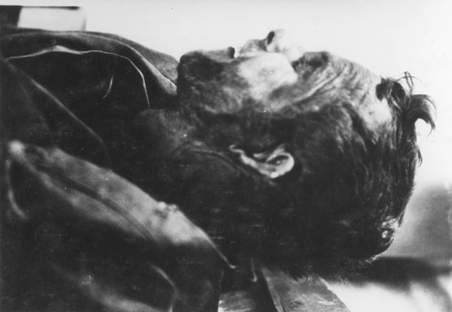
Albert Johnson
The forces of romance moved into the vacuum. It was said that Johnson had knowledge of a secret mine that kept his pockets filled with gold. It was said that he was a big-city gangster who had cached his loot in the Arctic, and in 1934 a band of treasure hunters searched the Rat River region without luck. It was said that the death of an Eskimo girl had driven him wild with grief.
A less fanciful supposition is that the man called Albert Johnson killed his Yukon partner—the owner of the gold teeth—and feared that the Mounties suspected him. But no one will ever know for sure what dark and guilty knowledge set him apart from his fellow men and impelled him to write in blood on the snows of the northland the legend of the Mad Trapper of Rat River.”
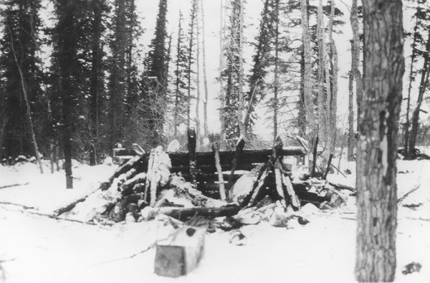
The remains of Albert Johnson’s cabin.
From Joe Healy’s web site RCMP Graves: “after being allowed to review the RCMP file on the death of Constable Millen: The method which I followed for the compilation of this story was to use a copy of the actual police report. Normally, a police report is purposely bland. The questions to be probed by the investigators are these; who, what, where, when and how many? These are the issues important to the judiciary. The use of adjectives, minute descriptions, weather conditions, the precise location of the moon in the sky, the colour of the dogs and harness and romantic notions are not part of a police report -- that is the job of journalists, researchers, authors, students and others.
To learn more about ‘The Tale of the Mad Trapper’, I encourage the reader to find the books written about the “Mad Trapper”.
I use [ ] brackets to insert or repeat names to help the reader.
In 1931, there were scant few RCMP in the Western Arctic. The full complement consisted of about eleven RCMP of various ranks under the command of one Officer, an Inspector.
The case began on July 12, 1931. A memo from Reg. #7536, Corporal Richard S. Wild, in Aklavik, NWT Assistant NCO on behalf of the Commanding Officer, Officer #5700, Inspector A.E. Eames was sent to Reg.#9669, Constable E. (‘Spike’) Millen, Constable In Charge of the Arctic Red River Detachment, ‘…it has been reported that a strange man going under the name of Johnson landed somewhere near Fort MacPherson on the evening of Thursday, July 9th, 1931.’
The memo said that Johnson arrived on a raft and that he owned very little kit but he had lots of money. Johnson had purchased supplies in MacPherson and he had enquired about the route into the Yukon. Constable Millen was asked to make enquiries about Johnson whenever he was in the area of Fort MacPherson.
Constable Millen replied to Inspector Eames on September 11, 1931. Constable Millen reported the following;
• he [Cst. Millen] met a man who identified himself as Albert Johnson on July 21, 1931 in Fort MacPherson,
• Albert Johnson told Cst. Millen that he had worked the previous summer and winter on the Prairies and that he arrived at Fort MacPherson via the MacKenzie River,
• Cst. Millen informed Albert Johnson that if he intended to stay in the MacPherson area, he would require a hunting licence which could be purchased at the Arctic Red River Detachment or in Aklivak. Johnson replied that he was undecided about his future plans,
• Albert Johnson told Cst. Millen that rather than live in Fort MacPherson, he preferred to live alone in the bush and that he didn’t want to be bothered by others. Cst. Millen found Johnson to be evasive in his replies. Johnson told Cst. Millen that if he [Johnson] did not stay in the area, that it was not necessary for the RCMP to know ‘all about him’. Cst. Millen did not follow up any further questions with Johnson,
• Later the same day, Cst. Millen interviewed Mr. Douglas, the Northern Trader at Fort MacPherson. Cst. Millen learned that Johnson was assembling some kit for a portage and that Johnson had purchased a canoe and other goods at the Hudson Bay Co.
• Mr. Douglas and Mr. Middleton, both of the H.B. C. told Cst. Millen that Johnson ‘…comes in and gets what he wants and pays for it and bothers no one.’
• In his report, Cst. Millen summed up that Johnson had no definite plans, that he [Cst, Millen] would re-interview Johnson again when he visited Fort MacPherson to determine where Johnson intended to settle. Constable Millen’s report was received by Inspector Eames. On August 11, 1931, Inspector Eames personally wrote a lengthy memo to Constable Millen.
Inspector Eames told Cst. Millen that he [Eames] was surprised that he [Millen] had accepted Johnson’s excuse for being evasive about his travel plans. Inspector Eames explained that it was important for the RCMP to know the intended address of men coming into the north in the event there was an accident or if a person was reported as lost. Cst. Millen was told to ‘…keep track of Johnson…’.
Further, Inspector Eames said, that under suspicious circumstances or, if necessary, the RCMP has the right to search a person’s kit under the Games Regulations. Johnson, instructed Inspector Eames, was to be encouraged by Cst. Millen to communicate with the RCMP about his whereabouts and his conditions as this was a common practice after ‘…the death of Nicol and Beaman on the Gravel River.’
In his conclusion, Inspector Eames said that if Johnson intends to travel to the Yukon, he should ‘…drop you (Cst. Millen) a line acquainting the RCMP of his safe arrival as this help to the RCMP can prevent long police patrols which sometimes are unnecessary.'
The next RCMP memo was written by Reg.#10269, Constable R. G. McDowell on January 2, 1932. Cst. McDowell said that he had acted on instructions from Inspector Eames and that he left Aklavik at 7:30AM on December 30, 1931 along with Reg.#10211, Constable A.W. King and Special Constables L. Sittichhiulis and J. Bernard. The destination of the RCMP patrol was the cabin of Albert Johnson which was situated on the Rat River near Destruction City, so called after many miners had perished on their way to the Yukon Gold Rush of 1898.
In his report, Cst. McDowell said the patrol (consisting of the four RCMP; McDowell, King, Sittichiulis and Bernard) reached Albert Johnson’s cabin at 10:30AM the following day which was December 31, 1931. Cst. McDowell approached Johnson’s cabin just as Cst. King knocked on Johnson’s door, at the same time shouting …’are you there Mr. Johnson?' There was an immediate shot through the door from inside the cabin. The shot hit Cst. King who fell, then got up and staggered into some bushes.
Cst. McDowell was able to secure his own rifle and began to shoot at the cabin so as to distract the occupant(s). Cst. McDowell was nearly hit by rifle fire on two occasions as he moved in the direction of Cst. King. In the meantime, Special Constable Sittichiulis was first to reach Cst. King. After reaching Cst. King, Cst. McDowell evaluated Cst. King’s condition as serious.
Cst. McDowell made the decision to immediately abandon an attack on the cabin. Instead, the patrol would strap Cst. King in a dog sled and race towards Aklavik. The patrol travelled all night and twenty hours later, they reached Aklavik. The date was January 1, 1932. Cst. King was admitted to All Saints Mission Hospital where he was attended by surgeon Dr. Urquhart.
Inspector Eames was told of Cst. King’s condition and how the police patrol to Johnson’s cabin unfolded. In turn, Inspector Eames sent a telex dated January 1, 1932 to Superintendent A. E. Acland –Commanding Officer ‘G’ Division, Edmonton, Alberta. Inspector Eames reported on the condition of seriously injured Cst. King.
Further, Inspector Eames reported that a complaint had been received by the RCMP of Johnson hunting without a games licence and of interfering with Indian trap lines. He concluded by revealing in the telex that ‘…McDowell brought King [to] Akalvik travelling eighty miles [in] twenty hours. Surgeon [Urquhart] reports bullet entered two inches below left nipple and emerged same place on right side. Am leaving to arrest Johnson when dogs rested probably Sunday morning.’
Over a matter of hours, a somewhat routine interview of Albert Johnson turned into a Criminal Code matter; Attempt Murder of a Police Officer. No small matter. Albert Johnson was a wanted man.
On January 12, 1932, Inspector Eames sent another telex to Superintendent Acland. In his detailed message, Inspector Eames said that he had led a new patrol to Johnson’s cabin and his group also consisted of: Constables Millen and McDowell, Interpreters [Special Constables] Bernard and Sittichiulis, three civilians and an Indian guide.
Inspector Eames said that due to poor information which was given to the guide, he and the group arrived at Johnson’s cabin on January 9, 1932. On approach to the cabin, the group was fearful of an ambush and that the area afforded little protection except for the banks of the [Rat] river. Johnson was commanded to leave the cabin but he refused. A decision was made to rush the cabin, but it was unsuccessful due to heavy fire from two automatic pistols from within. However, the door to the cabin was smashed with rifle butts and a quick peek inside revealed that the cabin was dug out five feet below ground level.
Gunfire continued between Johnson and the police patrol for fifteen hours during which time Johnson had time to repair and close the door. At three AM, the party used high explosives which blew in the door again and caused a hole in the cabin’s roof. Another rush to the cabin by the group failed. The patrol had expected that Johnson would be stunned by the explosives but instead his gunfire was increasingly strong. Inspector Eames speculated that Johnson likely had found shelter from the explosives by extending the limits of space under the cabin.
By this time, dog provisions were running low and other supplies for the patrol were depleted. Inspector Eames made the decision for the group to return to Aklavik. They arrived in Aklavik at four PM on January 12, 1932. In his telex, Inspector Eames said that no one in the group had been injured and that he would be returning to the cabin as soon as he could assemble a larger volunteer party. The next time, he said, a base camp would be established near the mouth of the Rat River.
On January 16, 1932, Inspector Eames’ Assistant, Corporal R. S. Wild sent a telex to Superintendent Acland in Edmonton, AB, saying that Inspector Eames had left Aklavik for the Rat River early that morning.
On January 31, 1932, Inspector Eames reported via telex to Superintendent Acland that Staff Sergeant Riddell of the Royal Canadian Signals had been placed in charge of a search group which included Cst. Millen. The search party found Johnson and Johnson fired on the group. The party took cover. Civilian Gardlund fired at Johnson when Johnson exposed himself from behind shelter.
Mr. Gardlund thought that he had hit Johnson, perhaps wounded or killed him. There was no further gunfire for the next two hours and the group felt that Johnson was incapacitated. The group decided to carefully approach Johnson’s position from different angles. The party consisted of Cst. Millen, Staff Sergeant Riddell and civilians Verville and Gardlund. When the party got to within twenty-five yards, Johnson opened fire and Millen was struck and fell. The remainder of the group was able to rescue Cst. Millen but he soon died.
The three remaining men guarded Johnson’s position so that he could not escape. Upon receiving word of the death of Cst. Millen, Inspector Eames began to rush every volunteer to the scene which he could muster. Inspector Eames also recommended that an airplane be requisitioned with Captain May as his preferred pilot. He said the plane was necessary as a search party could not remain in the field too long without provisions. Inspector Eames closed his telex by advising Superintendent Acland that he intended to leave Aklavik with the new pursuit party on Monday, February 1, 1932.
February 3, 1932. A telex was sent to Inspector Eames by Superintendent Acland. Inspector Eames’ request for an aircraft to assist in the pursuit of Johnson was approved by Commissioner Sir James Howden MacBrien. In the telex, Commissioner MacBrien instructed Inspector Eames to have Cst. Millen’s body transported part way out of the north by aircraft and then transfer it by rail into Edmonton. The Commissioner also wanted an update on Cst. King’s condition. Finally, the Commissioner told Inspector Eames to take Johnson’s fingerprints ‘…after capture whether dead or not and forward them quickest method.' The true identity of Johnson was still very much in question.
February 11, 1932. A memo was sent to Inspector Eames in Rat River by his Assistant, Corporal Wild in Aklavik. Cpl. Wild reported that Captain ‘Wop’ May took off in his aircraft from Aklavik with new provisions for the pursuit teams but Captain May had to return due to poor weather. Eventually, the weather cleared sufficiently so that Captain May could fly and safely land at Rat River a couple of times to deposit the provisions.
After depositing loads of supplies at Rat River, Captain May intended to pick the supplies up again and fly them to Inspector Eames’ base camp. Cpl. Wild ended his memo by suggesting to Inspector Eames that he [Inspector Eames] return some of the RCMP search party to Aklavik as a fresh supply of RCMP were prepared to replace them.
February 17, 1932. A short message from Corporal Wild to Superintendent Acland in Edmonton, AB said; ‘Inspector Eames reports Johnson shot and killed by Police Party on Eagle River today. Staff Sergeant Hersey, Royal Canadian Signals, member of party shot and seriously wounded by Johnson. Hersey is now in Hospital, Akalvik.’
February 18, 1932. A lengthy, four-page detail report was compiled by the C.I.B. Office in Aklavik. Statements provided by all the members at the Inquest that followed shortly afterwards, provided details of the sequence of events between February 11th and February 17, 1932.
The remainder of the file consists of RCMP memos which talk about the sightings of Albert Johnson and describe the possessions, guns and ammunition found on his person. Albert Johnson used every possible trick to evade capture. He exhibited the signs of an expert marksman. He had super strength to climb high mountains which other men could not imitate.
His true identity is still not known, his actions were never understood. He killed one member of the Force and wounded two others. Fortunately, Constable King of the RCMP and Staff Sergeant Hersey, Royal Canadian Signals both recovered from their gun wounds. In the end, though, the violence perpetrated by Albert Johnson was visited upon himself and he, too, was killed.
An Inquest was held … ‘a man known as Albert Johnson came to his death from bullets fired by a police posse endeavouring to arrest the said Albert Johnson for the shooting of Constable King and Constable Millen of the RCMPolice from information received from Inspector A. N. Eames, Q.M. Sergeant R. F. Riddell and Constable A. W. King.’
A ‘Warrant to Bury’ was authorized by Dr. J. A. Urquhart to bury Albert Johnson on February 18, 1932.”

Last of the Mad Trapper posse dies - CBC -Northern News Services
The last surviving member of the RCMP who took part in the hunt for the Mad Trapper has died. Cpl. Robert McDowell died Feb. 20, 2003, in Oliver, B.C., at the age of 94.
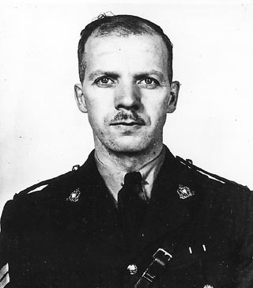
Corporal Robert McDowell – Reg # 10269
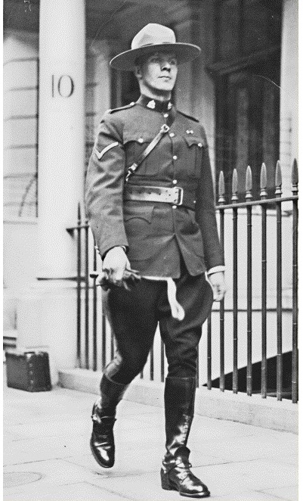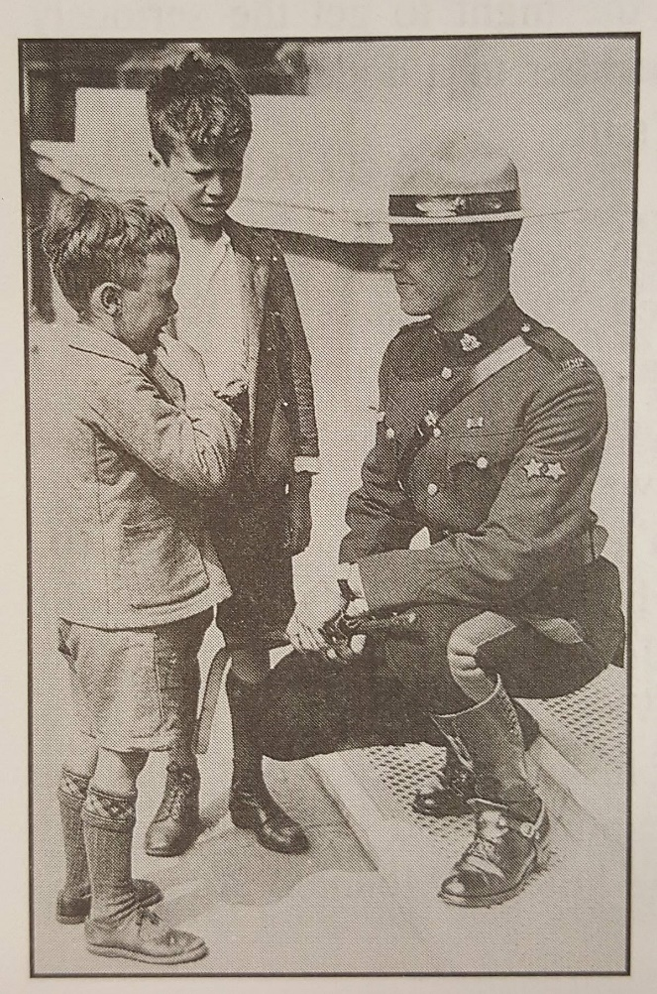
Lance Corporal Robert McDowell while in London serving at Canada House – 1939.
McDowell was part of the 21-person posse tasked with tracking Albert Johnson, "The Mad Trapper of Rat River," who led police on one of the most infamous manhunts in Canadian history.
McDowell had no children, but his nephew Jim Newbold said his uncle didn't talk much about the incident with Albert Johnson.
"He really kept it to himself," Newbold said. "It was just a matter-of-fact thing he had to do."
He was regarded as a top musher and a very athletic young man, during his posting in Aklavik.
"They relied on him to get sick people and rush medical supplies here and there," he said, adding that he loved his Northern posting." He would trade all his city life for the North."
Retired RCMP Insp. Hugh Westheuser interviewed McDowell and other retired members for a magazine article.
McDowell re-told the story of how they came across Johnson.
While investigating a complaint of theft from local traps, Const. Alfred "Buns" King from Arctic Red River paid a visit to Johnson's cabin at Rat River.
"He could see Albert Johnson inside, but he wouldn't respond to him," Westheuser said.
King left Johnson's cabin for Aklavik where he got a search warrant and detailed McDowell and special constables Wilson Bernard and Lazarus Sittichiulis to return to the cabin.
The group left Aklavik Dec. 28 and spent the night about 20 miles from Johnson's cabin. They arrived at the cabin about 10:30 a.m. the next day.
"Bob walked up to the door and King followed him," he said. "They announced that they were the police and they wanted to talk to him and kerbang, a bullet came through the door and caught King in the front part of his body."
"He staggered back and fell."
The special constables dragged King back to where the sleds were and McDowell fired several shots into Johnson's cabin.
McDowell retreated, emptied his toboggan and loaded King inside and set out on the 80-mile trip back to Aklavik.
Through the December darkness and 40-below temperature, the group spent the next 20 hours getting back to Aklavik.
"King was moaning and groaning the whole way," Westheuser said. "They did stop at a camp during the night to give the dogs a bit of a rest, but got to Aklavik about 8 the next morning."
"To me that's a pretty super-human feat," he said. "He told me his blood was pumping and he had to get King to medical help."
King went on to live a long life and died at the age 79 years.
McDowell injured his knee on the trip back to Aklavik and could not continue on the hunt for Johnson.
He spent four years in Aklavik and two years in Pangurtung, before accepting a post across the ocean at Canada House in London in 1938.
"He was the first red coat to be stationed over there," his nephew said.
Just before leaving for overseas, McDowell met and married his wife Una. The couple retired to Oliver, B.C., in 1955. Una died in 1979.
Sgt. Major Hugh Stewart, said with McDowell's passing, Canada has lost a formidable hero.
"We may have lost Cpl. Robert McDowell in body, but he will be forever alive as a legend in our hearts and minds," Stewart said.
Memorial service for Cpl. McDowell was held in Oliver last Tuesday. The service was televised. Six retired RCMP members served as honour guard.”
From the Wop May Diaries: the following is written by Wop May’s son Denny:
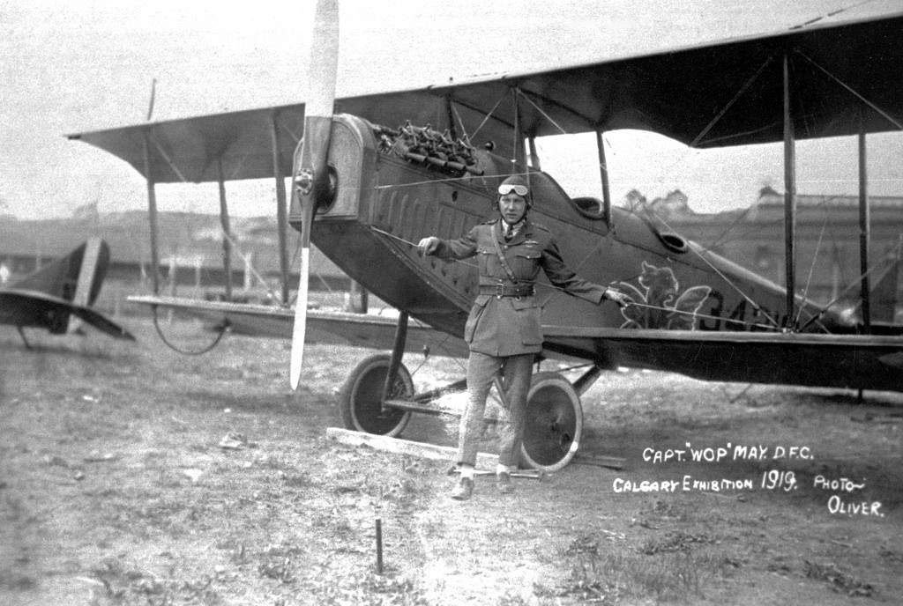
Canadian aviation legend Wilfrid “Wop” May
Many stories & books have been written about the Mad Trapper, some fictional accounts, others where the author has gone into more detail. There was one incredibly bad movie which defamed the characters involved. One of the frustrations I have is that authors tend to look at other works and repeat mistakes they made – a good check is the spelling of Wilfrid May – if it’s spelled Wilfred – then it’s wrong. In the case of the Mad Trapper episode one of the special RCMP constables was Lazarus Sittichinli – most authors have called him Sittichliulis in error. I had the opportunity to meet Lazarus & his wife at Aklavik in 1978 – a great man.
I would recommend the book “The Mad Trapper of Rat River” by Dick North as the best. Two other authors have written good historical accounts as well – Thomas P. Kelly wrote “Rat River Trapper” and Frank W. Anderson has two books published with the title “The Death of Albert Johnson” - these two books have great photos.
Another source of information is the web-site of the Royal Canadian Corps of Signals – their’s is a wonderful story – the web-site address is: http://www.nwtandy.rcsigs.ca/stories/rat_river.htm
– this address will take you directly to the story on their involvement with the search for the Mad Trapper.
I think rather than try and re-write the story (and risk creating more errors) I’ll put in the story my Dad told to the 12th Calgary Boy Scout Troop at their Father & Son Banquet on February 19, 1952. Fortunately, one of Scouters made a tape of his talk and gave it to me a couple of months later, after my Dad’s funeral. Here is the story as he told it.
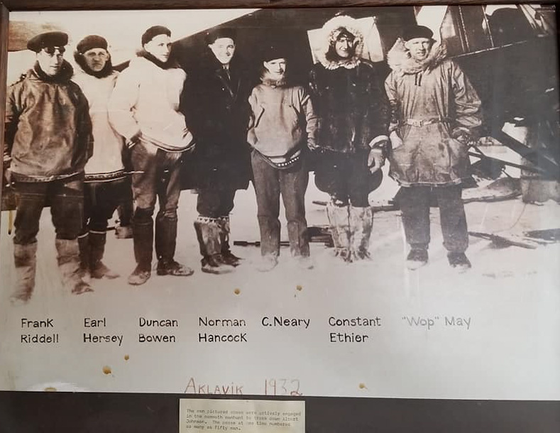
“Wop” May and some of his spotters and crew.
“Finally, I was called to go up and take part in the search. The first thing I had to do was to get them supplied with dog food, dried fish and then get their food stocks up. Where they had the camp at that time it was on top of a bald-headed mountain, well there were no trees there, anyway, it was more or less bare land. The district they were in was just east of the Yukon border. We got them all supplied and then started to try to find, to track Johnson down, to try to find him. It was very hard to see as there was no sun if you know what the light is like with no visibility and no sun, you can’t see anything, everything is white and it was very hard to pick up anything, you couldn’t pick up his tracks, although we did see some of his tracks, very few of them. His tracks could be seen in one place tonight and then tomorrow morning they would be seen 20 or 30 miles away. He travelled that distance in one night, sometimes he would go straight as a die. Anyway, we looked and looked and we flew low over every inch of the country that he could be, we were hoping he would fire at us, he wouldn’t have hit us anyway, but we wanted him to disclose his position, but he was too wise for that, he wouldn’t do it.
Finally it was just the time that the sun came up, the first day, I think, the sun appeared and it was shining on this mountain that was behind where we were working towards the Yukon which is the range of mountains which is the Yukon and N.W.T. boundary and the sun just hit the mountain and it would show up very clearly then and I just happened to get a glimpse of what I thought was a track going over the pass of this mountain. I went in closer to get a better look at it and sure enough it was a snowshoe trail. I went over the other side, on the Yukon side about 75 or 100 miles. We were now on the Yukon into La Pierre House.
La Pierre House was a place that in the olden days it used to take eight years to get supplies in to La Pierre House and get the furs back. Today you could do it in about 8 hours, you could certainly do it in 8 days by regular methods now. Quite a historic place. He had been there but when he crossed the Yukon the snow was much deeper than it was on the N.W.T. side. The snow over there is packed hard and you could walk on it very easily except when you got into sheltered places. Over there he had a hard time and he was slowing down, you could see where he was slowing down from his tracks, from the stops his made and from his tracks, he was not going straight.
We got the dog teams and the police moved over to La Pierre House. Then at that time I went out scouting again to try and pick up his tracks. I did pick up one set of tracks. He was fooling us actually, I’ll tell you about this, he was using the Caribou trail, running along the centre of the river, the Caribou are by the hundreds of thousands there and when they start making a trail and going someplace it’s just like pigs, they have a regular sidewalk. He had taken his snowshoes off and was following this Caribou trail so that we couldn’t trace him, track him. I did notice though that one place he had gone up to camp at the side of the river. He was then on the Eagle River. I gave the location to the Dog Team then Inspector Eames and he took a short cut and the next morning we were after him. They left early in the morning and I could not get out as early as I wanted to because of the fog.
Actually, we all met at the same place. I was up overhead when Alex Eames was coming round the bend of the river and Johnson was in the middle of the river. He tried to run up the bank to get out of his way, he didn’t have his snowshoes on, he couldn’t make it so he came back into the centre of the river, dug himself into the snow and the fight started.
We were up on top and circling, watching the fight and taking pictures of it. I then saw, during the fight, that one man was hit, he was laying by his dog team and he had been hit so I came around the bend of the river and came up to him and picked him up and started back home. He was badly hit. That was a chap named Hersey. He was kneeling when he was firing – it came through his elbow, out his elbow, through his knee, out his knee and in his arm, out his arm, just missed his heart, went right through him and the bullet was lodged just under his arm at the back. He was in bad shape and the blood was just spurtin’ out and there was nothing we could do for him, but get him in the aircraft and get him back to Aklavik where there was a hospital and a Doctor. We got him back there, but going through, as we hit the mountains there was a very heavy snow storm. If I hadn’t have known, if I hadn’t have been through there probably about a hundred times I wouldn’t have known I’d have never got through because I knew practically every stone, every turn in that pass and I was fortunate enough, with the help I was telling you about (God) to get through to Aklavik, and the Doctor said if we had been fifteen minutes later that Hersey would have died.
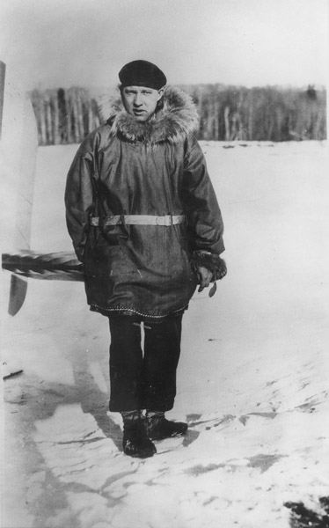
“Wop” May during the search for Johnson
Well, that was it, we went back then and we picked up the some of the police and picked up Johnson and brought him back to Aklavik. They never found out who this chap Johnson was, whatever his name was. He had about $2,400 in cash on him, he some pearls with him, he had a lot of gold teeth that he’d knocked the teeth out of out and kept the gold the bridge work, and he had a lot of pearls and a lot of fine gold too. Nothing was ever found out about the man, so they just buried him at Aklavik.”
One of the Scouts asked how many times he had been shot – he replied, “The last time I looked at him he about fifteen or twenty bullet holes in him. We’ve got one of them at home, haven’t we?” (the last question was directed to me (Wop May’s son – Denny May).
Frank Hersey, Soldier and civic politician 1905-2006 - Danny Gallagher, The Globe and Mail – March 2, 2006:
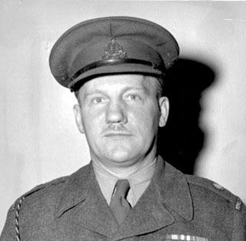

“In 1932, he was a young army signaller borrowed by the RCMP in its hunt for the Mad Trapper of Rat River. For weeks, he and a posse of about 20 chased a desperate gunman across the frozen wilderness.
Frank Hersey was the last surviving member of the posse that tracked down the Mad Trapper of Rat River during a 240 km chase along the Artic Circle in 1932. A party of more than 20 Mounties, soldiers, natives and trappers tracked Albert Johnson for weeks I -40 temperature. By the time the trek ended in the middle of a frozen river, two men were dead and two others were badly wounded. One of the wounded was Mr. Hersey.
It all began with a complaint by trappers that Johnson was interfering with their trap lines. According to author Dick North, Johnson was probably Johnny Johnson, a convicted murderer from North Dakota, who set foot in Fort MacPherson, NWT, on July 9, 1931. After a series of complaints, RCMP Constables Alfred King and Joe Bernard set out in late December of 1931 to question Johnson. The next day, they found a cabin he was believed to use, but when one of the officers peered through a window, someone blocked it with a burlap sack. The officers retreated and returned several days later with three additional men.
“Are you there, Mr. Johnson?” Constable King shouted through the door. The fugitive responded by firing a bullet through a hole in the door, badly wounding the officer. The posse retreated, travelling 20 hours to get treatment for him [Cst. King].
Several days later, an even bigger party returned to lay siege to the cabin. After 15 hours of gunplay, a bomb was hurled onto the roof and he cabin collapsed. When the posse went looking for a corpse, Johnson stood up from a fox hole and started shooting. The siege had failed. Johnson disappeared into the wilderness and he RCMP returned to Aklavik, NWT, to assemble a more sophisticated posse.
It was then Frank Hersey joined. A former high school teacher from New Brunswick, he had joined the Canadian Army in 1927, spending six years in Aklavik as a communications expert, helping to construct and operate a radio station that broad to Edmonton. As part of the Royal Canadian Signal Regiment, he had vast experience in the north, became familiar with explosives and was a crack rifleman. He was also an experienced musher.
“My dad was chosen because he had the fastest dog team…seven huskies”, said Mr. Hersey’s daughter Shelia. “He had the lead team. He was so familiar wit the north and good on tracking. He was single in those days and he would always want to be doing something. He bred his dogs with wolves. Not withstanding his competence with do teams, Mr. Hersey’s involvement in the manhunt marked the first-time two-way radio was used by the police in Canada. Another first was the use of an airplane in such an operation. While the posse travelled via dogsleds, First World flying ace Wop May, an experienced bush pilot, searched from the clouds in a Bellanca monoplane equipped with skis. As a young pilot during the war, it was May whom the legendary Red Baron (Manfred von Richthofen) was pursuing when the German ace was downed and killed (for years history says it was Canadian Capt. Roy Brown that shot down the Red Baron, but there is much controversy, it is now claimed that it was gunfire from the ground that brought the Red Baron down).
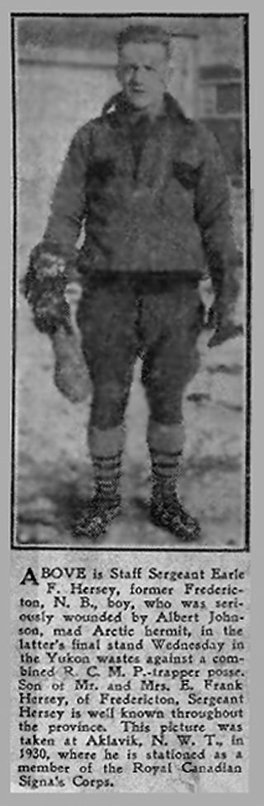
The search for Johnson was a formidable assignment. The fugitive eluded the posse in what was the coldest winter on record, using wilderness skills that seemed almost superhuman. Strapping on his snowshoes and weighed down by a backpack full of pots, household goods and food, the stock muscular man of 35 was still capable of travelling two miles for every mile covered by the dogsleds.
At one point, the posse’s advance party stumbled on a hut to be met by gunfire. Johnson scrambled behind a fallen tree and a two-hour interval unfolded in which nothing happened. Finally, Constable Edgar Millen, became concerned that Johnson would escape and moved closer. Johnson fired several shots, striking Constable Millen in the heart. It was Mr. Hersey who next day retrieved the body. The pursuit went on for weeks until on Feb. 17, Wop May spotted snowshoe tracks on the Eagle River and radioed Mr. Hersey. Within hours, some of the posse caught up to Johnson. Going down on one knee, Mr. Hersey shot at the desperado three times at a range of about 80 metres.
“I didn’t want to kill Johnson. I have trouble killing flies”, Mr. Hersey once told The Quarterly, an RCMP magazine. “I’d hit his back three times…and down he’d come and he was just disgusted with me. He reached behind and got the rifle and bang. He hit me dead center. I had fallen and gone over backward and down in the snow. He fired three more times at me as I lay in the snow and didn’t hit me once. I was hit through my left knee”.
Meanwhile, Johnson seemed untouched until finally a freak shot changed everything. An RCMP bullet found the spare ammunition Johnson carried in his backpack and it exploded. Johnson was seriously wounded and the posse moved in for the kill. The fatal shot was a bullet in the spine. By some accounts, it was he of 17 bullets fond lodged in his body. Police recovered $2,410 in cash on him, along with gold fillings from corpses, a pocket compass, a razor, knife fish hooks, a dead squirrel and a dead bird.
With the mission accomplished, Mr. Hersey’s life was on the line. The only man hurt in the final shootout, he was scooped up by May and flown to the hospital in Aklavik. “Without Mr. May’s quick action, my dad would never have made it”, his daughter Shelia said. “He was shot through the knee and the bullet then went into an elbow and into his chest. They found it embedded in flesh in his back.”
The Johnson adventure spawned several books including those written by Mr. North, several television productions and a fictionalized movie “Death Hunt”, starring Charles Bronson and Lee Marvin. Recently, it was featured on the History Channel’s “Manhunt” series.
Frank would always carry the bullet with him. The bullet from Johnson’s gun”, RCMP Chaplain and historian Gerry McMillan said. “Hollywood mad a movie a number of years ago about the Mad Trapper but it was poorly done and far from being true to the account.”
Mr. Hersey remained in Aklavik for another year before he was transferred. Over time, he received postings to such place places as Kingston, Montreal, Alberta and Barrie, ON, where he eventually settled. Drawing on his experiences in the north, the army called on him in early 1946 to participate in Exercise Muskox, a trial to determine if snowmobiles could replace dogsleds. The 2,900 km expedition ended with a reception in Edmonton in May. It was also during his army days that Mr. Hersey had the great fortune of winning $157,000 in the Irish Sweepstakes, exceptional coin for those days. During the Second World War, he served in the army’s Signal Corps Armoured Division, landing in Sicily. Somewhere along he way in Italy, he got to meet the Pope.
Mr. Hersey retired from the army in 1955 at the age of 50 and settled in Barrie, where he became involved in local activities. Mr. Hersey served on Barrie City Council for 16 years. He was voted Barrie’s Citizen of the Year in 1960.
Frank Hersey was born on August 6, 1905, in Fredericton, NB. He died in his sleep on January 1, 2006 in Elmvale, near Barrie, ON. He was 100 years of age.
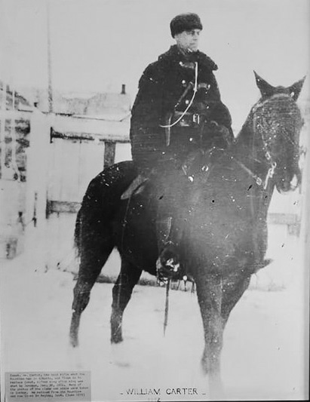
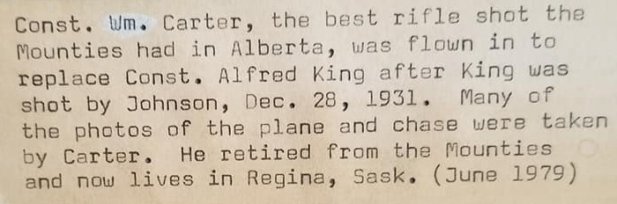
William Carter – Reg # 10186

From Joe Healy’s RCMP Graves website:
Alexander Neville Eames was born in Wales on December 26, 1883. We can deduce that Eames was a modest man for he never mentioned the social status of his family or the fact that his parents employed a Governess, a General Servant and a Grooming Servant. His family must have been fairly well-to-do.
There is no reference to Eames’ early schooling in Wales, however, it was noted that he was well read and confident in conversation. As well, his penmanship was excellent and his writing was noticed by his superiors from the earliest days of his RCMP career. It is thought that he may have been home schooled by the Governess in the employ of his parents. A letter of recommendation to the RCMP written on his behalf described Eames as being strictly sober, honest and extremely willing to work hard.
Eames arrived in Quebec City on August 5, 1913 as a passenger on board the ship ‘Sicilian’. He paid $22.50 for a one-way train ticket from Québec City to Regina, SK.
Eames had a stellar career in the RCMP; he was an extremely hard worker and his perseverance was quickly noticed by senior Officers; he was prompt, fast to learn, reliable and trustworthy. He joined the Force with considerable experience and it was clearly noted on his application that he could ride a horse. It was not long before he came to the attention of senior Officers.
He established a solid work ethic in Regina which impressed his Inspector -- who requested of the RCMP Commissioner that Eames be paid .25$ more per day while Eames was employed as Quartermaster and as a Mail Orderly. The request for a raise was approved.
After Regina, Eames was then transferred to Red Deer, AB. His Commanding Officer recognized Eames as, “... one of our smartest and most-painstaking non-commissioned officers who was very efficient and always conscientious.” His superior Officers could rely on Eames and he was transferred several times wherever he was required.
In March 1917, Eames was promoted to Corporal and soon he became the Acting Quarter - Master Sergeant in Calgary, AB. In 1919, he was selected to open Pincher Creek Detachment. In this new role, he was granted $0.50 extra pay per day which was very timely as he was soon to marry.
In April 1918, Eames volunteered to go overseas with the Canadian Expeditionary Force of the Royal North West Mounted Police Cavalry. He was sent to England arriving on May 18, 1918, just six months before Armistice Day. He was then sent to France and it was reported that Eames saw real action during WWI.
He was awarded both the General Service Medal and the Victory Medal. Eames was discharged from the C. E. F. on March 14, 1919 and he returned home. Upon his return to Canada, Eames was recommended for promotion to Staff Sergeant, but to his consternation, 'HQ' declined his superior Officer's advice. Instead, he received his Commission on February 1, 1920 and he was promoted to Inspector. His annual salary was $1200.00 per annum.
A.N. Eames was transferred to Edmonton, AB. in 1920 and to Fort Norman, NWT in 1924, to Vancouver, BC in 1926 and to Herschel Island, YT in 1929. It was during this time period that Inspector Eames led the RCMP in the hunt for the Mad Trapper. The famous and well documented chase which took place over the winter of 1931 - 1932 was just one highlight of A. N. Eames’ long and distinguished RCMP career.

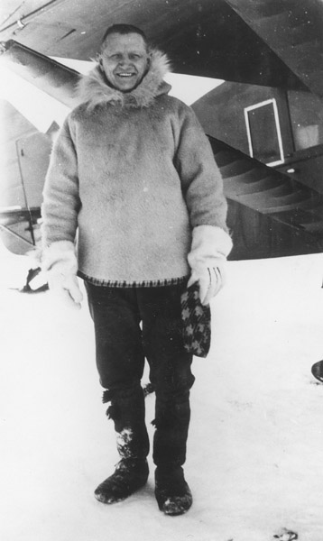

Insp. Eames during the search for Johnson
In April, 1943, A. N. Eames was promoted to Assistant Commissioner in Halifax, NS and he was designated as the Commanding Officer (CO) of Nova Scotia.
In July, 1946 Eames was awarded the prestigious Order of the British Empire (O.B.E.) and on August 15, 1946 after a 33-year career in the RCMP, he retired to pension. His annual pension was calculated to be $3700.00. Assistant Commissioner Eames enjoyed retirement on Canada's west coast for almost 20 years. He and his wife had no children but they travelled throughout BC and became reacquainted with old friends. A. N. Eames died at the age of 81 years on January 13, 1965 at his Vancouver home.
A religious service was held for A. N. Eames and according to newspaper accounts the ceremony was well attended by members of the RCMP as well as two elderly sisters from Wales. After the church service, his body was taken to Ocean View Cemetery in Burnaby, BC for cremation. Records show that Mrs. Eames paid for the funeral service and for his cremation. Ironically, it is in the death of A. N. Eames that part two of our mystery unfolds.
After my retirement from the RCMP in 2001, I designed a very unique online database to record the discovery of all RCMP graves stretching back to 1873. Hundreds of volunteers from across Canada and from around the world have joined in to help me with the discovery of RCMP graves.
One day in 2009, I received a very curious message from a volunteer living in Calgary. He reported that he could not find the grave of A. N. Eames.
As soon as I read the name of A. N. Eames, I was startled to attention because I could not believe that one of the most illustrious members of the RCMP and one of my heroes seemed to be unaccounted for in death.
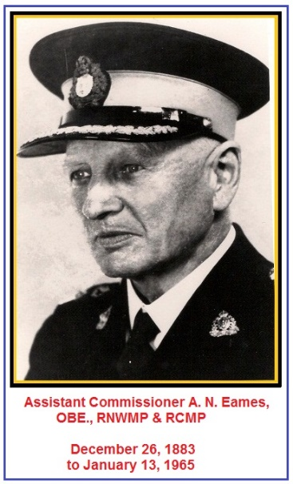
I thought to myself, “Did someone forget to bury Assistant Commissioner Eames?” It was a dilly of a question for Canadians familiar with RCMP history, and the saga of the Mad Trapper. I was determined to find A. N. Eames, but I kept my quest to find his urn a secret.
I learned from Eames’ Death Certificate held in Vancouver, BC that he had been cremated in January 1965.
I called Ocean View Cemetery in Burnaby, BC., and, although their records showed the date of his cremation, they could not find his urn. For several months leading up to Christmas 2009, Ocean View reported that they had no luck finding Mr. Eames’ urn. In January 2010, Ocean View called with very, very exciting news. A grounds keeper assigned to the search had finally found Eames’ urn -- about six long months after the search had first begun. Mr. Eames’ urn was found in a warehouse among many thousands and thousands of other forgotten and unclaimed urns.
After hearing the news of discovery, I wondered to myself, “How could Assistant Commissioner Eames’ final remains have been left untouched at Ocean View Funeral Home since he died in 1965 until their discovery in 2010 – or, for nearly 45 years?” I asked Ocean View if I could adopt Mr. Eames’ remains and give him a respectful burial. Ocean View said that the Eames’ urn would be shipped to me in Ottawa by Air Canada.
True to their word, Ocean View put the special parcel on Air Canada. I was very, very relieved as I finally took possession of Assistant Commissioner Eames’ remains. His wife, Margaret Louise Eames died in 1983 at the age 100 years. She had lived another eighteen years after Alexander Eames had been cremated -- but she had not buried him. That surely is another mystery - perhaps in her old age Mrs. Eames forgot about him or maybe she couldn’t afford the additional expense.
I never guessed that I would someday meet one of my long-time heroes under such unusual circumstances -- after all, the parcel was abruptly tossed to me in the doorway of our home by Canada Post much like a full, forward rugby pass. I buried Assistant Commissioner Alexander Neville Eames in a private ceremony at the RCMP National Memorial at Beechwood Cemetery in Ottawa, ON.
It was a very, very special honour and an emotional, historical event for me to lower his urn into its final resting place.
J. Healy
April 23, 2011

Garry Rogers - I’m a retired Royal Canadian Mounted Police homicide detective and investigator with the British Columbia Coroners Service:

“Over the years, a number of possible identities were offered for who ‘Albert Johnson’ really was.
The most widely accepted theory was Arthur Nelson, a prospector who was known to be in British Columbia from 1927 to 1931 and had left for the Arctic. Photos of Nelson appeared to be a dead-ringer for ‘Albert Johnson’ and descriptions of Nelson’s effects (rifle, pack, and clothing) were identical to those recovered from Johnson.
Another promising lead was a man known as John Johnson, a Norwegian bank robber who’d done time in Folsom Prison. Again, the physical description was similar and the Scandinavian accent noted by Constable Millen seemed to fit.
The Johnson family of Nova Scotia identified the Mad Trapper as their lost relative, Owen Albert Johnson, who was last heard of in British Columbia in the late 1920’s. Again, all the pieces fit – physical appearance, personal effects, and disposition.
Sigvald Pedersen Haaskjold was suggested as being the real ‘Albert Johnson’. Haaskjold, who was last seen in northern British Columbia in 1927, was a recluse who was paranoid of authorities because he’d evaded conscription in the First World War. He’d built a fortress-like cabin near Prince Rupert before disappearing. Once more the looks, age, accent, and mentality fit the Trapper’s profile.

As with advances in 1930’s technology like the radio and the airplane which tracked ‘Albert Johnson’ down, forensic technology in the twenty-first century came into play for a once-and-for-all attempt at solving the mystery of who the Mad Trapper of Rat River really was.
In 2007, seventy-five years after his death, ‘Albert Johnson’ was exhumed for another look. As part of a Discovery Channel documentary, a team of eminent scientists including forensic odontologist and DNA extraction expert Dr. David Sweet, forensic pathologist Dr. Sam Andrews, and forensic anthropologist Dr. Owen Beattie, examined the skeletonized remains.

This forensic story is every bit as exciting as the hunt for the Trapper himself.
It took a pile of wrangling to get legal approval for exhumation, then obtain the consent of native peoples who laid claim to the land in which the Trapper was interred. Due to permafrost, there was only a slight window of time when the archeological dig could be made. And the exact location of the grave was in doubt.
Perseverance came down to the last available day when the team and film crew zeroed-in on a shallow grave with a rotten, wooden casket. Using archeological skill and precision, the forensic scientists carefully detached the lid and exposed a perfectly preserved male skeleton. There were no longer traces of flesh or fabric, but what gleamed in their faces was gold bridgework from a sneering skull. Dr. Sweet used dental records made in 1932 to positively identify the ghostly remains as that of the Mad Trapper.
The team cataloged the bones, making three interesting observations. One was a deformity in the spine which led to questions as to how the man could have performed the physical feats described in legend. Second was that one foot was considerably longer than the other, again questioning his mobility. And third was the entry and exit marks of a bullet path through the pelvis which was consistent to the reported fatal wound.
The team had the right remains but were no further ahead in determining identity. Dr. Sweet sectioned the Trapper’s right femur and extracted bone marrow samples as well as pulling four teeth for DNA examination. The remains were replaced in a new casket and re-interred in the original grave.
Back at the University of British Columbia, Dr. Sweet and his colleagues developed a perfect DNA profile of the Trapper. Extensive field investigation located relatives of the primary suspects – Arthur Nelson, John Johnson, Owen Albert Johnson, and Sigvald Pedersen Haaskjold. Descendant DNA profiles were developed for these men and compared to the known biological signature of the Trapper.

And guess whose DNA matched?
No one’s.
All four suspects were conclusively eliminated by modern forensic technology as being the Mad Trapper – as were a number of other remote possibilities. One side-note is that oxygen isotopes developed from the teeth enamel indicated that the Trapper originated from either the mid-western United States or from Scandinavia.
So, who really was Albert Johnson, the Mad Trapper of Rat River?

The mystery of who lies in the Aklavik grave remains unsolved.”

